IMAP Gmail Settings To Be Followed.

1. Allow access to Less secured Apps .

Follow the Link Given below and sign into the email account which you are trying to monitor and set the Access to Less Secured apps.

<https://myaccount.google.com/lesssecureapps>

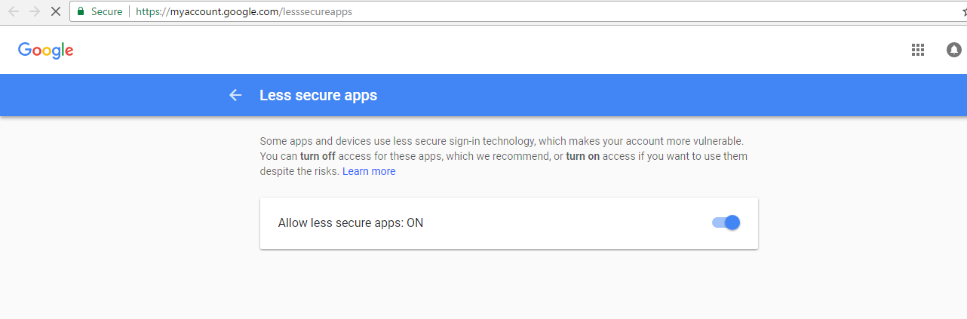

This will allow access to the account for the applications we create.

1. Enable IMAP Listner for the gmail Account.

Go To Settings of the account as shown below

